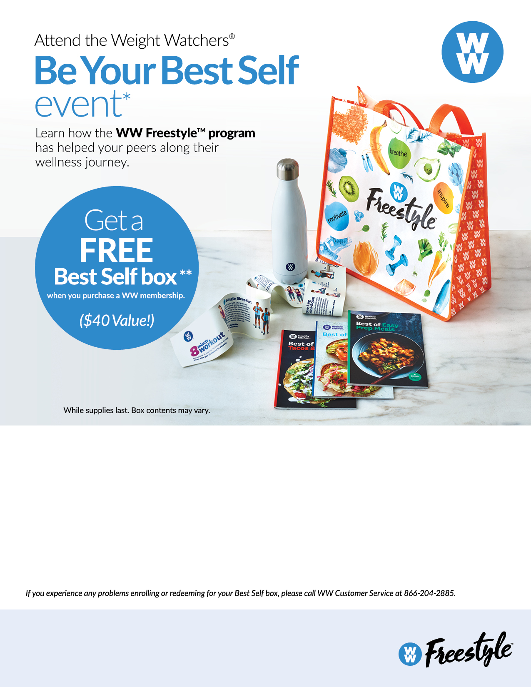

**Step 1**

Once enrolled, redeem for your Best Self box by going to weightwatchers.com/atworkgift, and enter your member registration number and shipping address. Complete this step by 11/16/18.

Attend the WW Be Your Best Self event at your workplace:

Date & Time: Thursdays 12:15pm – 12:45pm

Room: [Hurley Convergence Center](https://convergence.umw.edu/) #111

**Step 3**

Enroll by going to https://wellness.weightwatchers.com, input the UMW Employer ID: 6359, Employer Passcode: WW63569. Follow the instructions to enroll.

**Step 2**

Registration will be available (most major credit cards and personal checks are accepted).

Be Your Best Self event does not include Program materials or weigh-in.

**FREE BEST SELF BOX:** You must purchase a Online*Plus*, Meetings + Online*Plus* or Weight Watchers for Diabetes membership through your employer or health plan between 10/15/18 and 11/2/18 to get free box. Available only where meetings in the workplace are offered, and in participating areas only. One kit per member. Once you join WW, you will be given instructions on how to redeem your box. Box must be redeemed by 11/16/18. While supplies last. US addresses only: no P.O. boxes or APO/FPO boxes. Please allow at least 3-4 weeks for delivery. Offer not available to current members. Offer may be revoked at any time and may not be redeemed for cash. Non-transferable. Void where prohibited.

The WW Coin logo and Weight Watchers are the registered trademark of Weight Watchers International, Inc.   
WW Freestyle is the trademark of Weight Watchers International, Inc.

©2018 Weight Watchers International, Inc. All rights reserved.

**\*\***

*