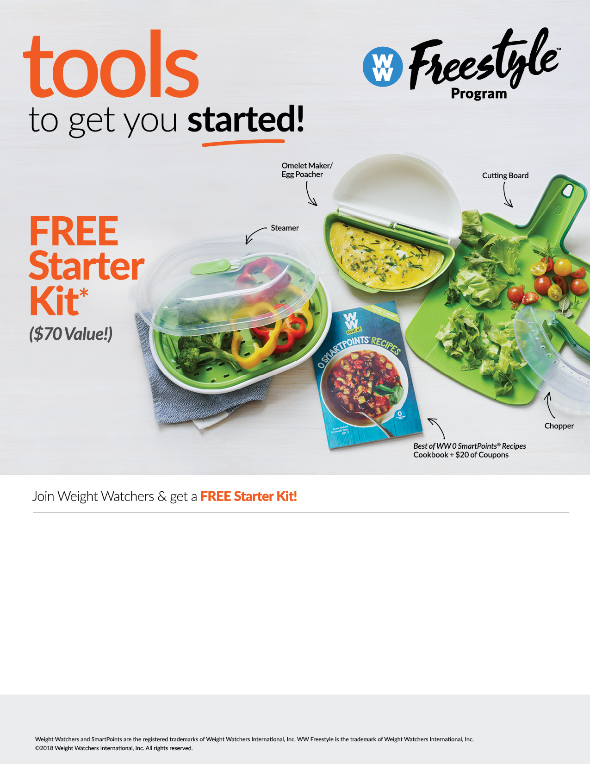

**Purchase a Weight Watchers**® **membership** between 9/4/18 and 9/21/18 to get a

**\*FREE STARTER KIT OFFER:** You must purchase a Meetings + Online*Plus* or Online*Plus* membership between 9/4/18 and 9/21/18 to get free kit. Kit includes 5 popular products valued at $70 including $20 worth of coupons. Available only where Weight Watchers memberships are offered through your workplace or health plan, and in participating areas only. One kit per member. Kit must be redeemed by 10/5/18. While supplies last. US addresses only: no P.O. boxes or APO/FPO boxes. Please allow at least 3-4 weeks for delivery. Offer not available to current members. Offer may be revoked at any time and may not be redeemed for cash. Non-transferable. Void where prohibited.

*If you experience any problems enrolling or redeeming for your starter kit, please call Weight Watchers Customer Service at 866-204-2885.*

After buying a membership,  
you **must redeem your Starter Kit online by 10/5/18**, while supplies last. Starter Kit contents may vary.

**Step 1**

Enroll in Weight Watchers by going to https://wellness.weightwatchers.com, and input the UMW Employer ID: 63569, Employer Passcode: WW63569.  Follow the instructions to enroll.

Once enrolled, redeem for your Starter Kit by going to **weightwatchers.com/atworkstarterkit** and enter your member registration number and shipping address. **Complete this step by 10/5/18.**

**Step 2**

Registration will be available (most major credit cards and personal checks are accepted).